Sustainable Landscape Training
March 20, 2012
Homework Assignment:
Complete before attending class on March 20.
Review the pdf document “Sustainability Training Outline”.
Review at least one Sustainability PowerPoint presentation in the UCANR Repository. Use the following instructions to gain access to the correct repository through the UCANR portal. You will not be able to gain access by going through the San Diego Master Gardener portal
Go to: ucanr.org/portal
Login using your UCCE SD MG ID and password
Click on: Repository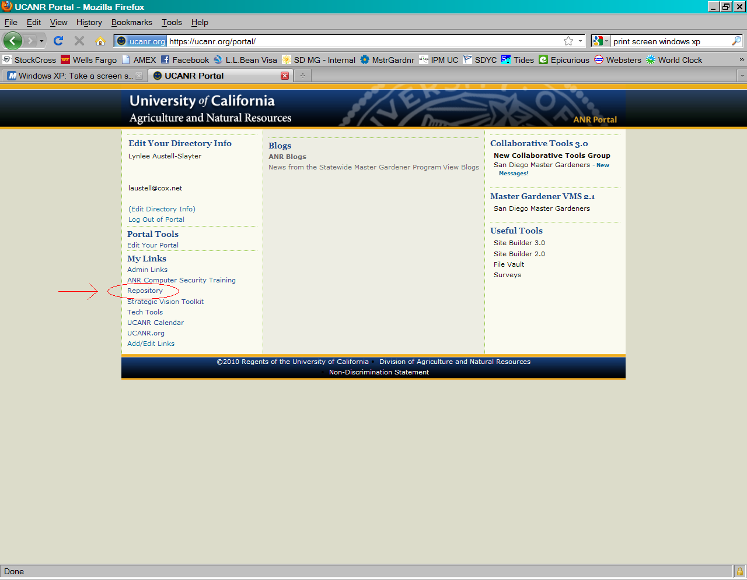

Click on: View Special Libraries
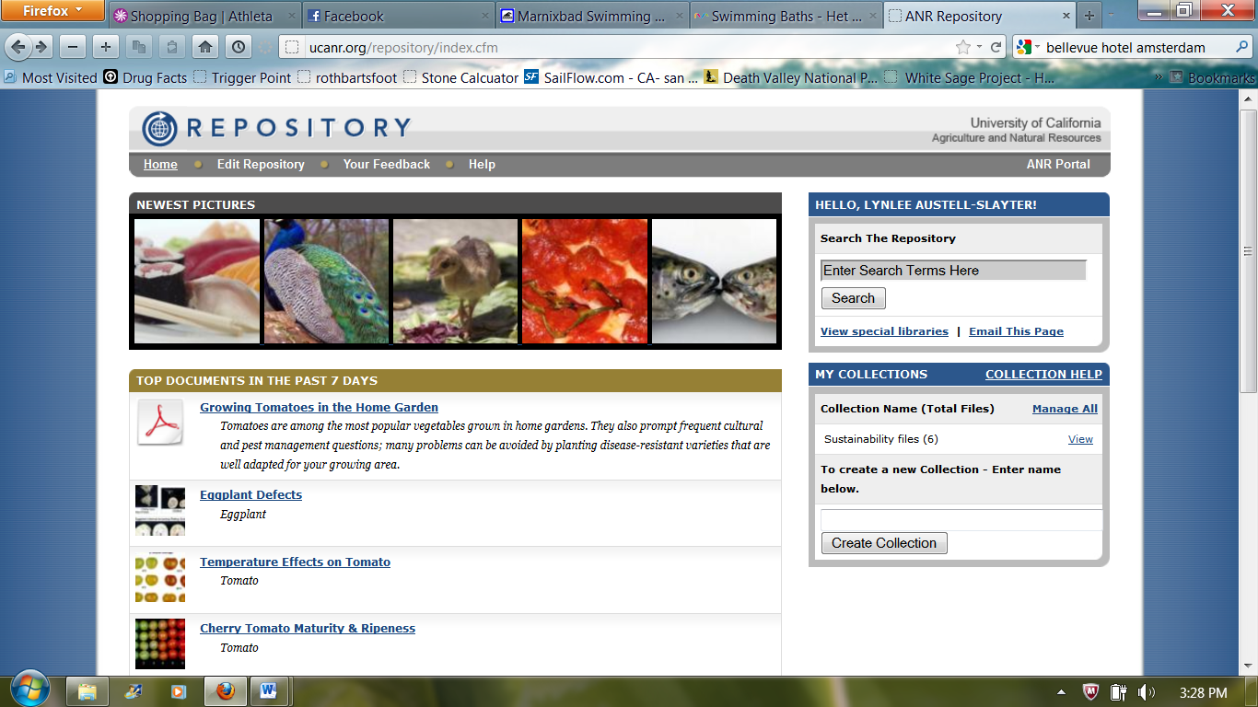
Click on: Master Gardeners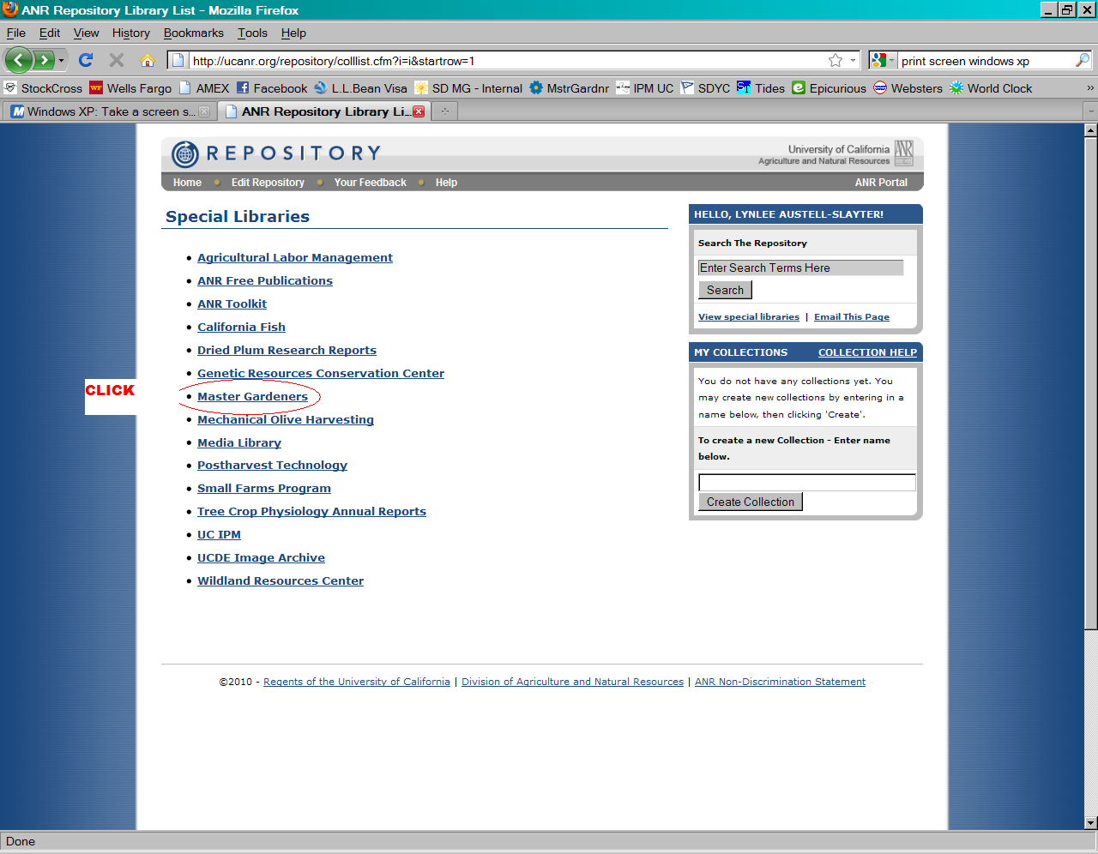

Click on: Sustainable Landscape Training 2010
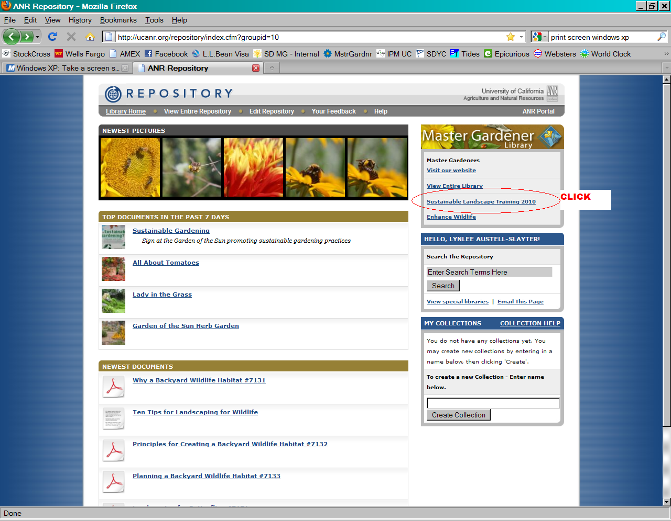

At this destination, chose at least one PowerPoint presentation that interests you to review before class. You may view all if you wish.
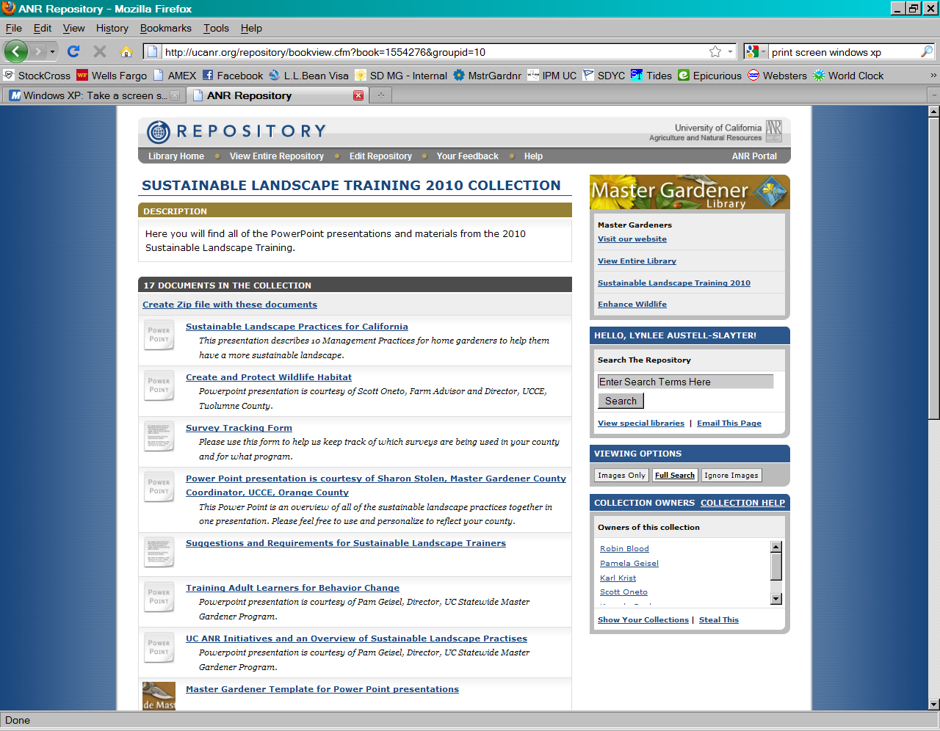
The 17 documents in this special library were used at the 2010Sustainable Landscape Expert training sessions throughout California.

